**Path-Goal Leadership Theory**

The Path-Goal model is a theory based on specifying a leader's [style](http://www.nwlink.com/~donclark/leader/leadstl.html) or behavior that best fits the employee and work environment in order to achieve a goal (House, Mitchell, 1974). The goal is to increase your employees' motivation, empowerment, and satisfaction so they become productive members of the organization.

Path-Goal is based on Vroom's (1964) [expectancy theory](http://www.nwlink.com/~donclark/leader/leadhb_2.html#Vroom) in which an individual will act in a certain way based on the expectation that the act will be followed by a given outcome and on the attractiveness of that outcome to the individual. The path-goal theory was first introduced by Martin Evans (1970) and then further developed by House (1971).

The path-goal theory can best be thought of as a process in which leaders select specific behaviors that are best suited to the employees' needs and the working environment so that they may best guide the employees through their **path** in the obtainment of their daily work activities (**goals**) (Northouse, 2013).

While Path-Goal Theory is not a detailed process, it generally follows these basic steps as shown in the graphic below:

1. Determine the employee and environmental characteristics
2. Select a leadership style
3. Focus on motivational factors that will help the employee succeed

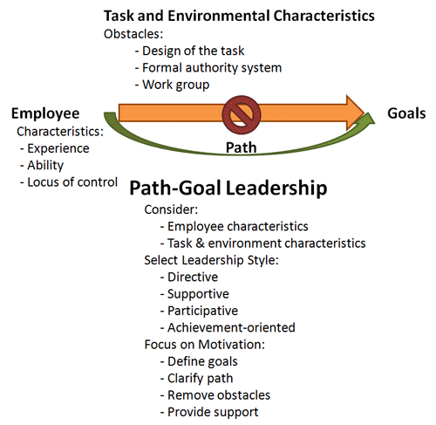

**Employee Characteristics**

Employees interpret their leader's behavior based on their needs, such as the degree of structure they need, affiliation, perceived level of ability, and desire for control. For example, if a leader provides more structure than what they need, they become less motivated. Thus, a leader needs to understand their employees so they know how to best motivate them.

**Task and Environmental Characteristics**

Overcoming obstacles is a special focus of path-goal theory. If an obstacle becomes too strong, then the leader needs to step in and help the employee select a path to work around it. Some of the more difficult task characteristics that often arise are:

* Design of the task - The design of the task might call for the leader's support. For example, if the task is ambiguous, then the leader might have to give it more structure or an extremely difficult task might call for leader support.
* Formal authority system - Depending upon the task authority, the leader can provide clear goals and/or give the employee some or all control.
* Work group - If the team is non-supportive, then the leader needs to be cohesiveness and espouse esprit-de-corps that provides comradeship, enthusiasm, and devotion to all team members.

**Leader Behavior or Style**

The independent variables of Path-Goal Theory are the leader's behavior — the leader adjusts her style of behavior to the employee and task characteristics so that the employee's motivation is to excel at their goal.

House and Mitchell (1974) defined four types of leader behaviors or styles: Directive, Supportive, Participative, and Achievement (explained in detail below). They are based on two factors that were identified by an Ohio State University study behaviors (Stogdill, 1974):

* **Consideration** - relationship behaviors, such as respect and trust.
* **Initiating Structure** - task behaviors, such as organizing, scheduling, and seeing that work is completed.

The first behavior listed below, Directive, is based on *initiating structure*. The other three (achievement, participative, and supportive) are based upon consideration.

The four path-goal types of leader behaviors are:

* **Directive**: The leader informs her followers on what is expected of them, such as telling them what to do, how to perform a task, and scheduling and coordinating work. It is most effective when people are unsure about the task or when there is a lot of uncertainty within the environment.
* **Supportive**: The leader makes work pleasant for the workers by showing concern for them and by being friendly and approachable. It is most effective in situations in which tasks and relationships are physically or psychologically challenging.
* **Participative**: The leader consults with his followers before making a decision on how to proceed. It is most effective when subordinates are highly trained and involved in their work.
* **Achievement**: The leader sets challenging goals for her followers, expects them to perform at their highest level, and shows confidence in their ability to meet this expectation. It is most effective in professional work environments, such as technical, scientific; or achievement environments, such as sales.

The leaders' behavior is not set in stone, as there are other [leadership styles](http://www.nwlink.com/~donclark/leader/leadstl.html) that may be used depending upon the situation. For example, House (1996) defined four other behaviors:

* Work Facilitation
* Group Oriented Decision Process
* Work Group Representation and Networking
* Value Based

**Application**

As noted earlier, the independent variables of Path-Goal Theory are the leaders' behavior, thus the path–goal theory assumes that people (leaders) are flexible in that they can change their behavior or style, depending upon the situation. This coincides with the research that while nature (genes) may be our internal guide, nurture (experience) is our explorer that has the final say in what we do (Ridley, 2003).